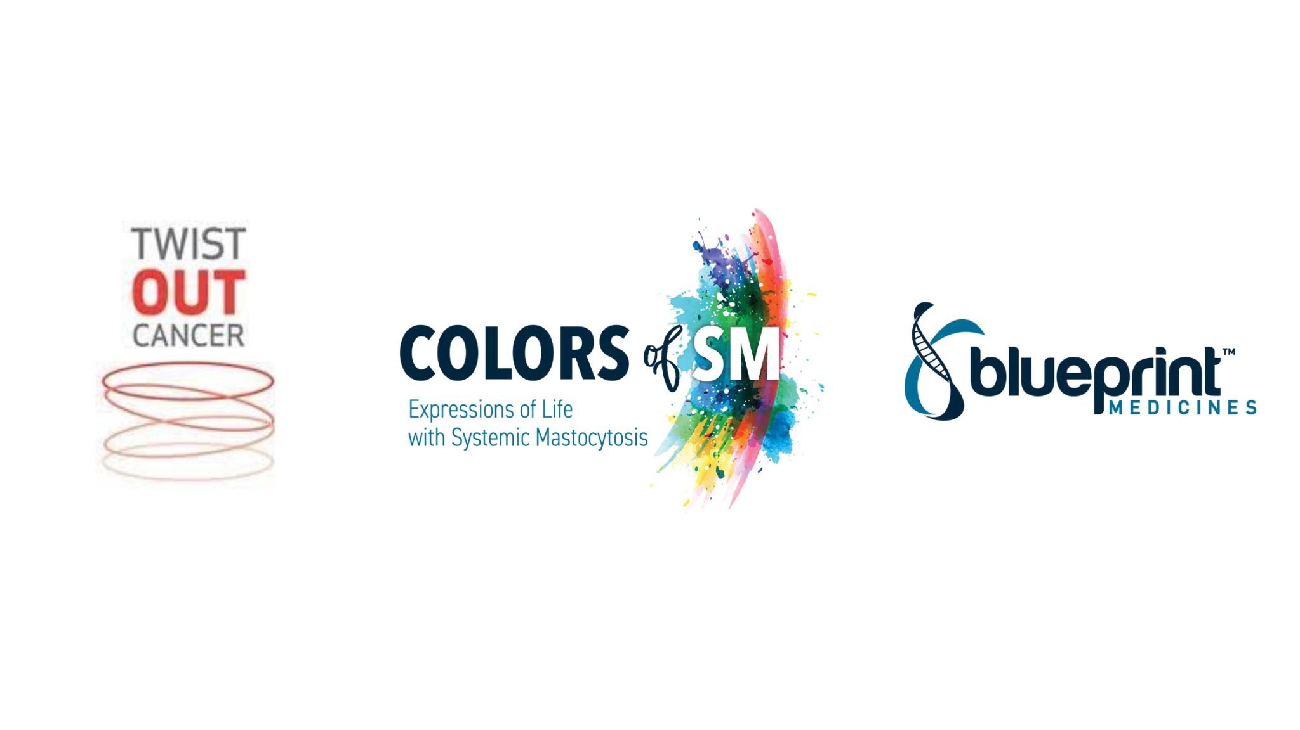

Colors of SM: Expressions of Life with Systemic Mastocytosis

Twist Out Cancer provides psychosocial support to individuals living with a variety of health conditions through creative arts programming, which serves as a mechanism for healing.

Twist Out Cancer has partnered with Blueprint Medicines, a biopharmaceutical company studying oncology, hematology, and rare diseases, to further amplify its mission to share, connect, and heal. Together, Twist Out Cancer and Blueprint Medicines have developed Colors of SM: Expressions of Life with Systemic Mastocytosis, which is a 4-6 month program that matches individuals touched by systemic mastocytosis (identified as “Inspirations”) with talented artists that work in a variety of mediums. The Inspiration is tasked with sharing their story with the Artist, as they create a unique work of art that is reflective of their journey with SM. As the relationship develops, the Artist is able to turn what is notoriously isolating and scary into an experience that is filled with beauty and hope. The Inspiration and Artist relationship is supported by a mentor that is trained to offer additional resources and guidance.

The Colors of SM: Expressions of Life program will culminate in July with a celebratory event for Inspirations and Artists, where the artwork will be used to raise awareness of systemic mastocytosis.

What is systemic mastocytosis?

Systemic mastocytosis (SM) is a rare disease estimated to occur in approximately 32,000 adults in the U.S. It is a disorder where abnormal mast cells – a type of white blood cell that plays an important role in managing immune responses – accumulate in different parts of the body such as the skin, heart, gut, bones, and other organs. People living with SM may experience more than 20 symptoms, which can be chronic, unpredictable, debilitating, and some may be potentially life-threatening. Because mast cells are present across your body, these symptoms may involve skin (itching, flushing, hives), gastrointestinal (abdominal pain, diarrhea, nausea), systemic (anaphylaxis, fatigue, weight loss), neurologic (anxiety/depression, headache, lack of focus/brain fog) and more. Triggers, or what may cause symptoms, can vary widely for those living with systemic mastocytosis and change over time.

Apply to be an Artist here.

